

**User Documentation for Code for Nepal Website Upkeep**

**By Alex John, Haley Hurst, Sean O’Connor, Katie Hibner, and Mike Kenyon**

**Log-in to Wix.com to access the prototype** **3**

**Changing Login Credentials** **5**

**Viewing Test and Vaccine Center Submissions** **5**

**Adding Test and Vaccine Centers to Database Page** **8**

**Changing RSS Feed** **10**

**General Wix Tips** **13**

# Log-in to Wix.com to access the prototype

1. In order to access the prototype, type wix.com into your browser.

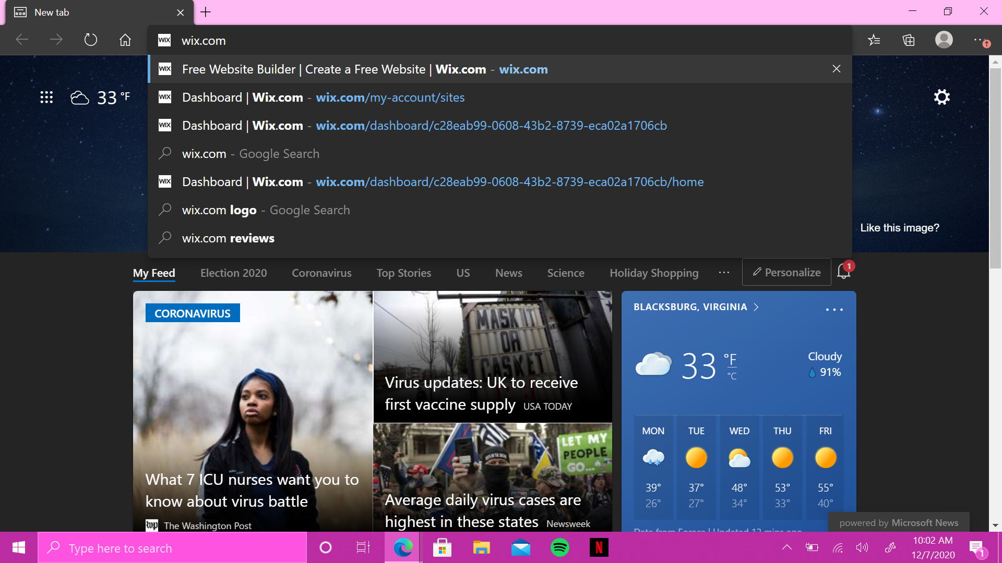

1. Click **sign in** in the upper right corner of the Wix home screen.

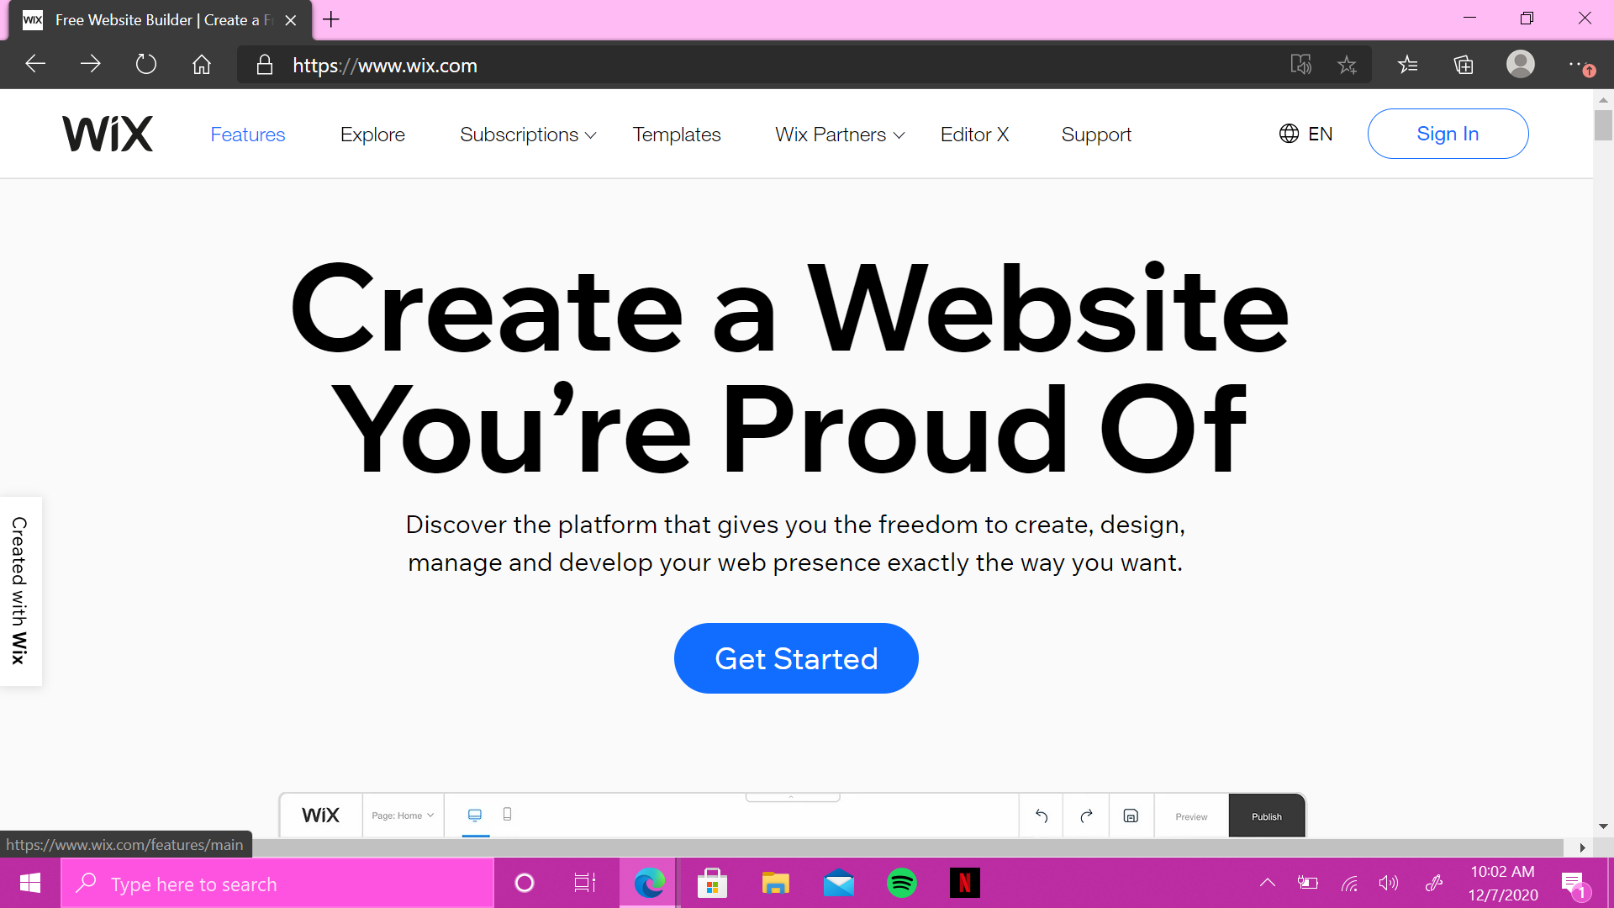

1. In the email box, type [haleykhurst3@gmail.com](mailto:haleykhurst3@gmail.com).

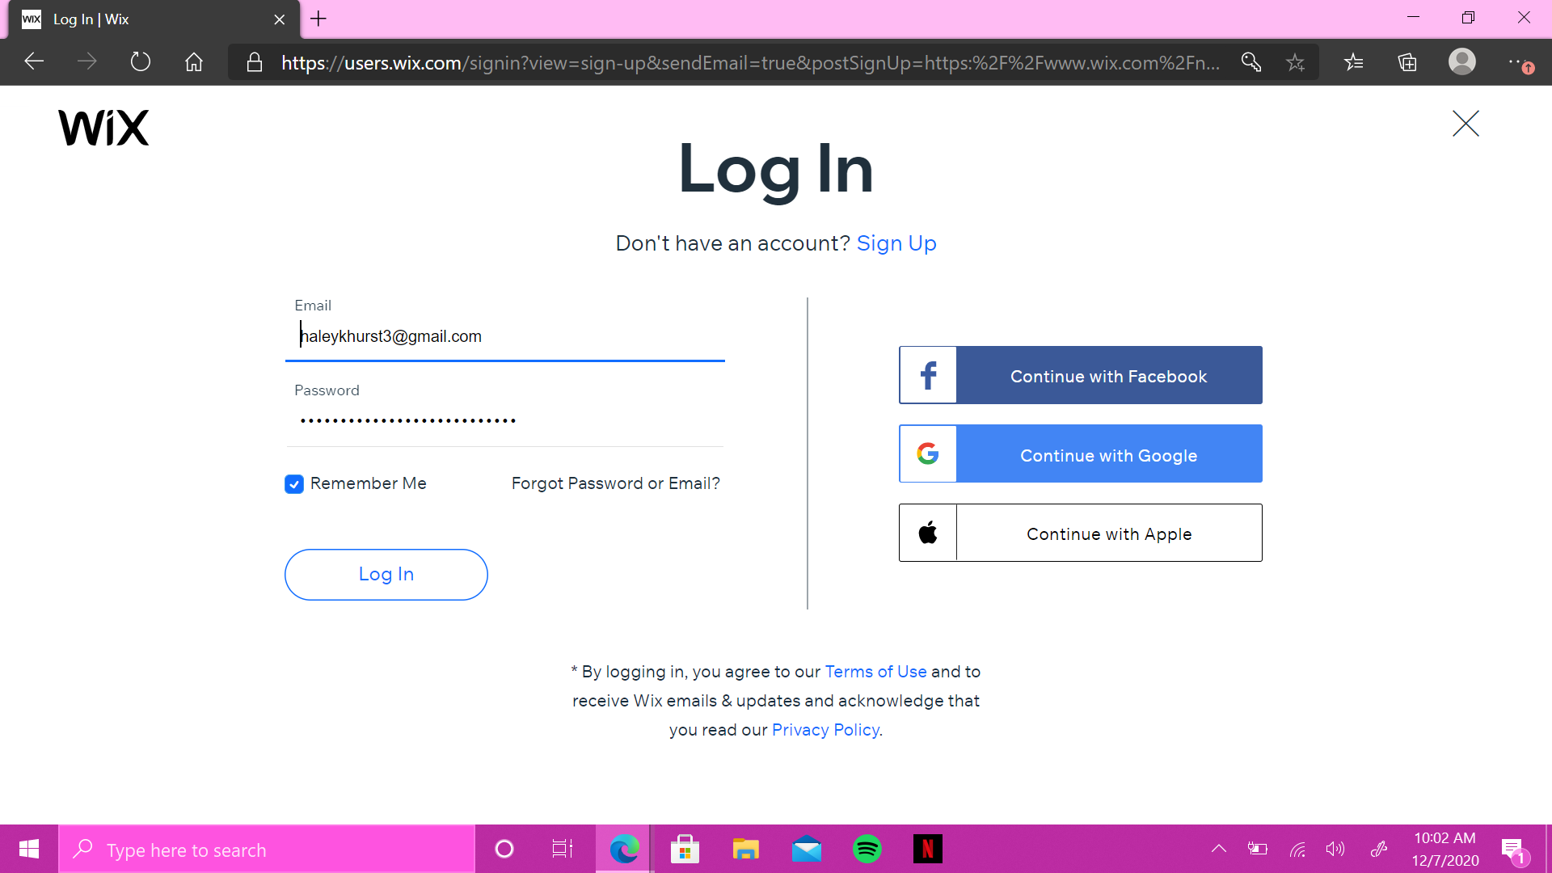

1. In the password box, type Creating User Documentation



1. Click **log in.**



1. You should be redirected to the page below.

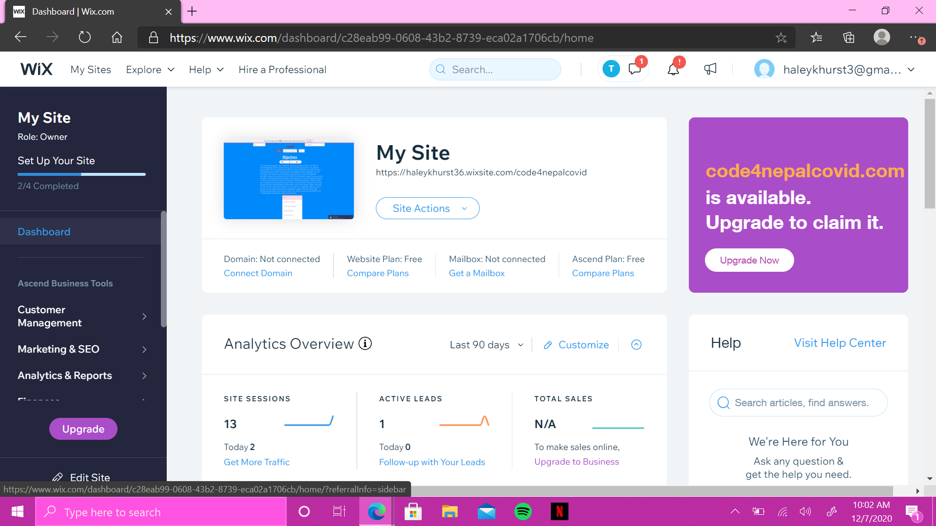

# Changing Login Credentials

# Viewing Test and Vaccine Center Submissions

1. From the dashboard, click on **Site Actions** and select **Edit Site** from the dropdown menu. This will take you to the Wix Website Editor in a new tab.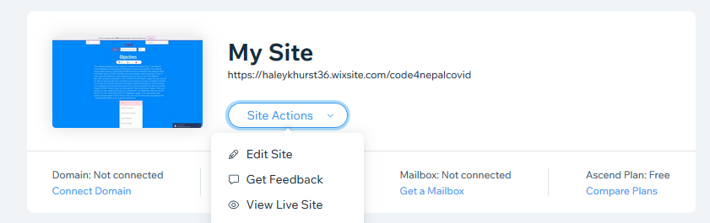
2. At the top and in the center of the page, there will be a **Page** dropdown menu titled **Contribute To The Project**. Click on this and then select either **Add Test Centers to Database**  or **Add Vaccine Centers to Database**. 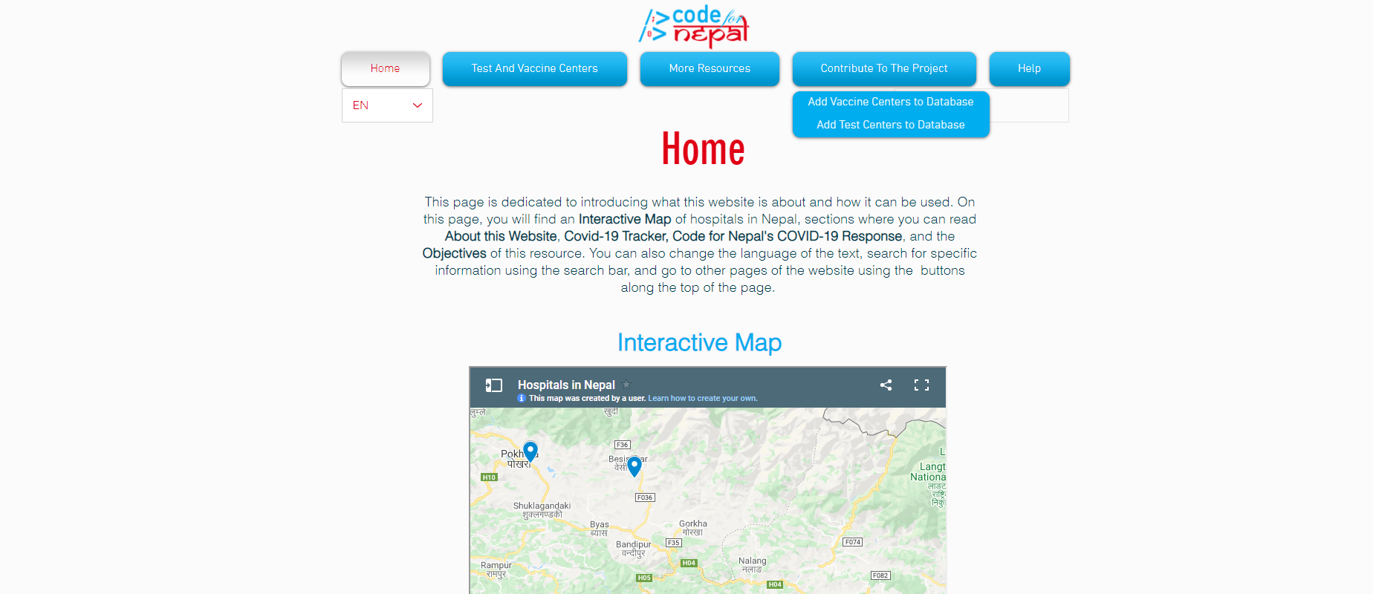
3. Click once on the form, then click on the **Form Settings** button that appears above it. 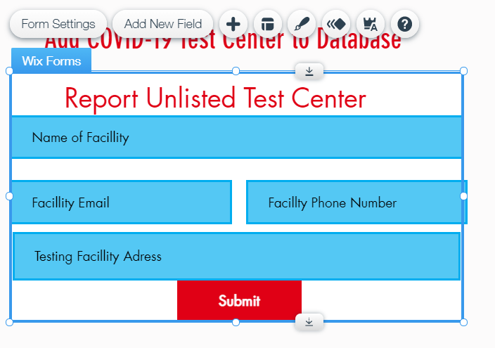
4. A panel will appear to the side of the form. Click on the **View Submissions Table** button in the center of the panel.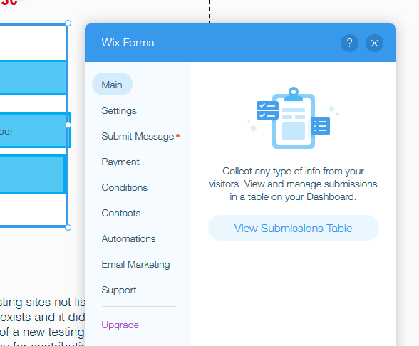
5. A panel covering the entire page will appear displaying the submissions table. From here, the submissions can be filtered, sorted, and exported.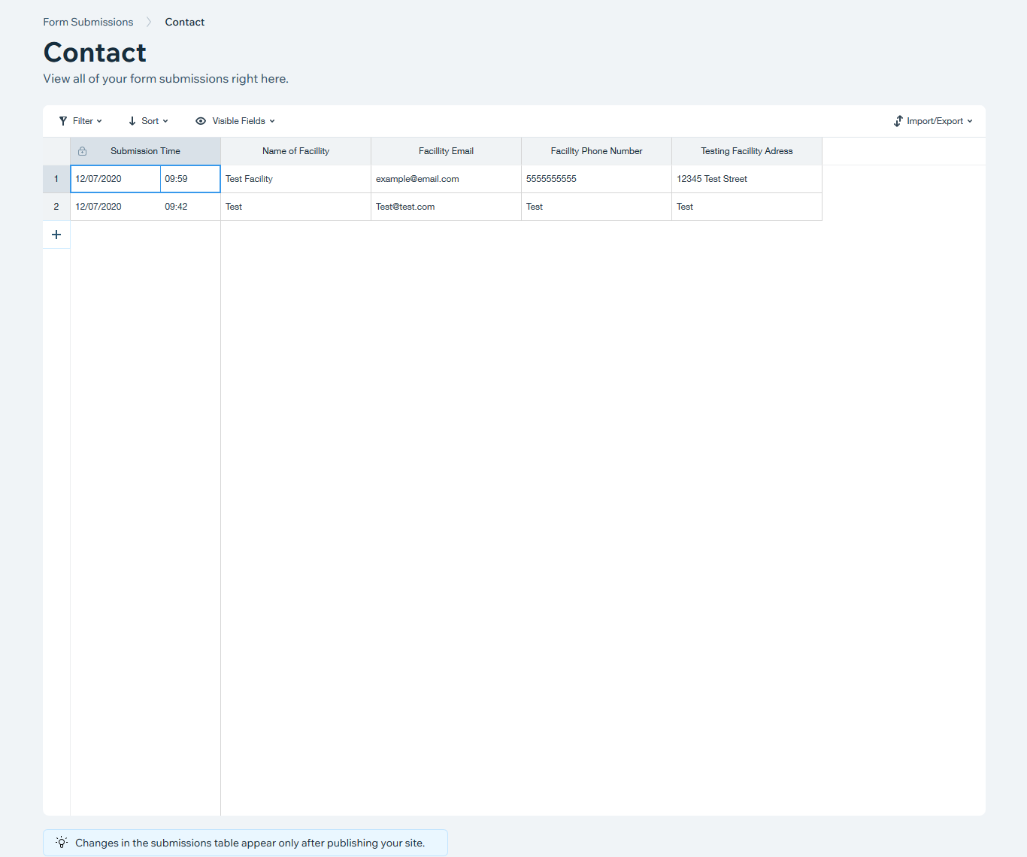

# Adding Test and Vaccine Centers to Database Page

1. Click on the **Contribute To The Project** dropdown menu at the top of the editor. Select either **Add Test Center to Database** or **Add Vaccine Center to Database**. 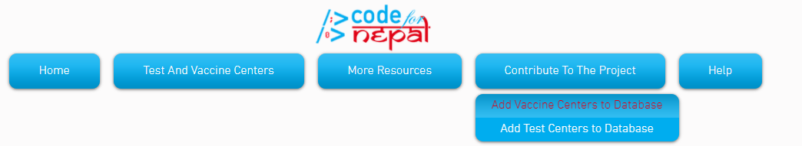
2. On the left hand side of the screen, while in edit mode, click on the **Media** button. Then click the **Show More** text at the bottom of the window that it opens up.  
   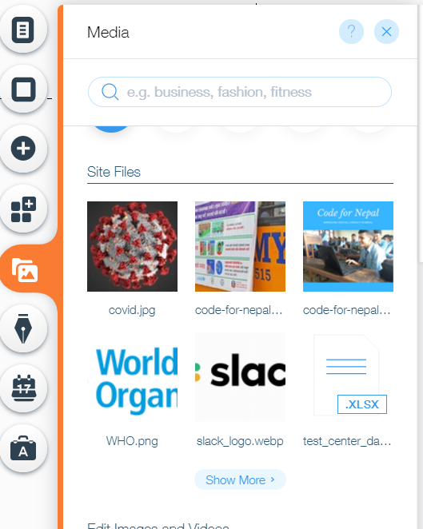
3. In the menu that pops up, download the database you are looking for. (In the example there is only a **Test_Center_Database.xlsx**, as no vaccine centers exist at this time). Download the database.xlsx file, and add the information into the table into the Name, Location format that it uses. After that, save the file, delete the old file, and reupload.

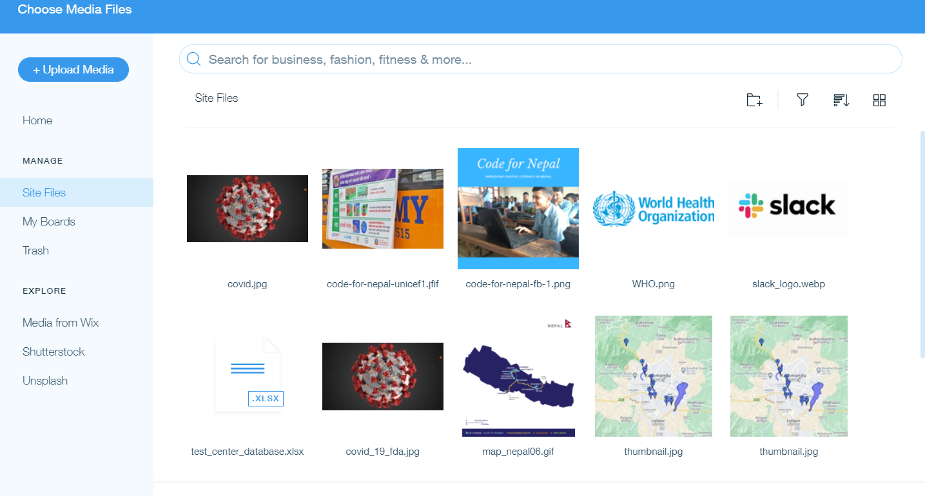

1. The file can be downloaded on the respective page. So, to download the test center database file as a normal user, navigate to the **Test and Vaccine Centers** Tab, and select the **Test Center Database** dropdown. Click on the Big X, or the file name below it to download the excel file.

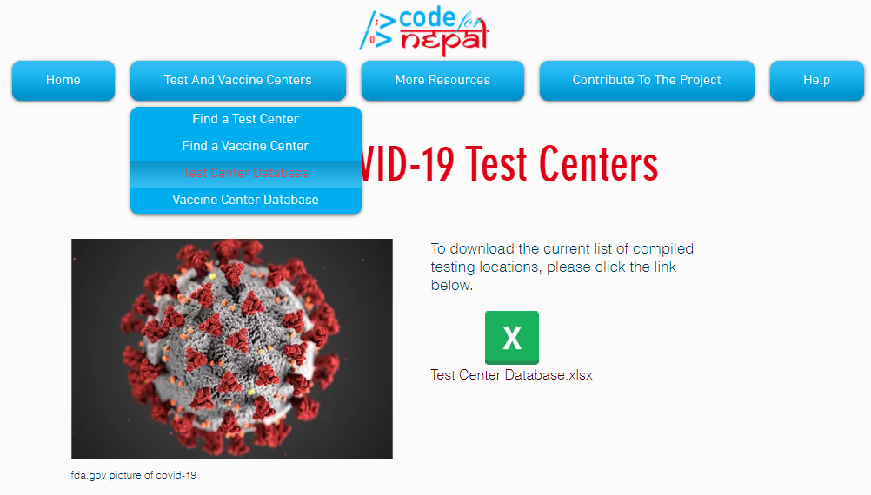

# Changing RSS Feed

Taggbox, an application that displays RSS feeds, was used for this website. We created our own account for this, but it may be more beneficial for Code for Nepal to create their own account. There is a free option, but the site pushes very hard to get its users to pay. This will document how to change the RSS feed associated with the widget that is currently on the website under our account. If you end up creating your own account, the site should guide you through how to create your first widget, and you should be able to export it to Wix through embedding its HTML code.

1. Navigate to <https://taggbox.com> and click **Log In** in the top right corner.

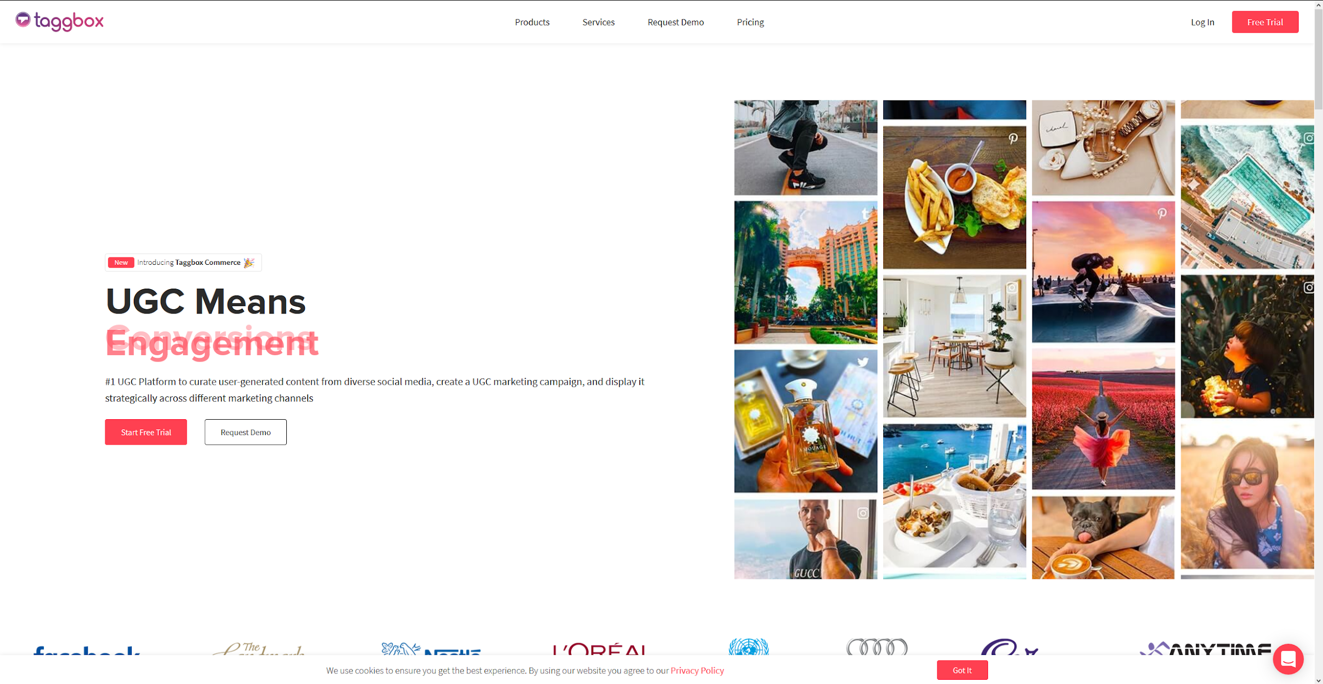

1. Enter [**soconnor00@vt.edu**](mailto:soconnor00@vt.edu) as the username and **Creating User Documentation** as the password, then click **Log In**.  
   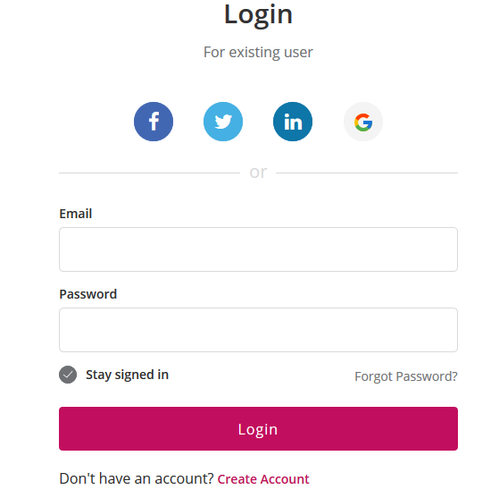
2. You will be taken to the dashboard. Click the **Edit** button on the first wall.  
   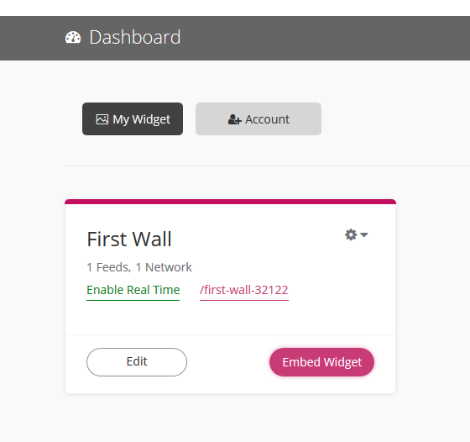
3. In the widget editor, click on the **Feeds** dropdown menu. This will display two options: **Add Feed** and **Manage Feeds**.  
   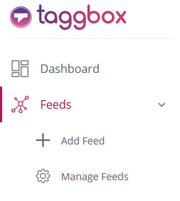
4. To add a feed, click the **Add Feed** button. Click the button corresponding to the source you want to use and follow the prompts from there.  
   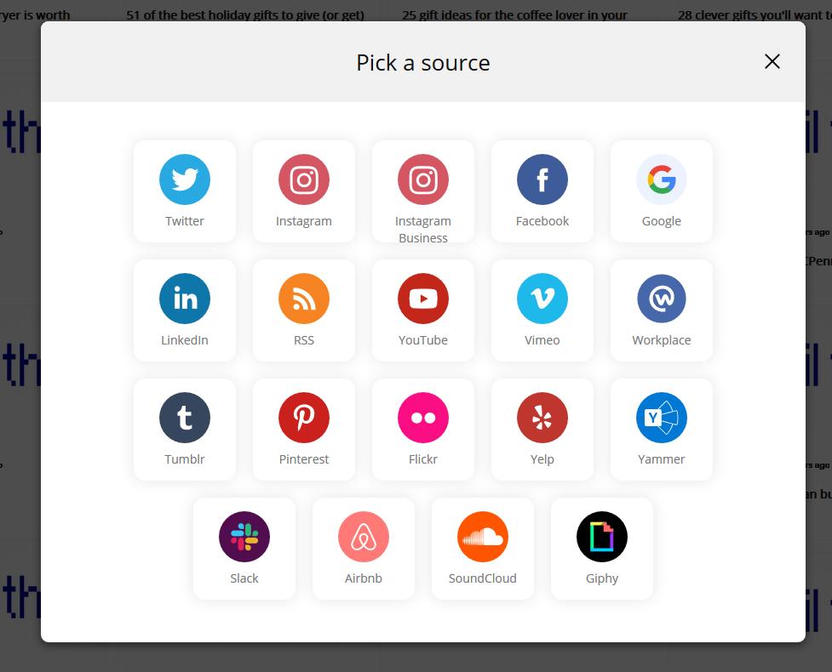
5. To remove a feed, click the **Manage Feeds** button. A dialog with all current feeds will be displayed. To remove one of them, click on the **Trash** icon.  
   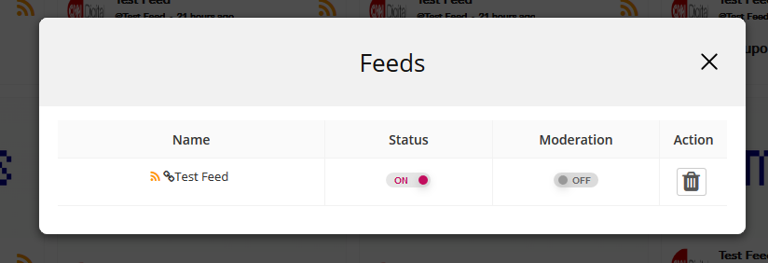
6. The feed on the Wix site will eventually refresh with updated information depending on the Taggbox account’s plan.

# General Wix Tips

* There are plenty of help pages and tutorials for Wix available on <https://support.wix.com> and other parts of the internet.